
ENGREG HIGH SCHOOL
24, Bankole Street, Pedro, Shomolu, Lagos
WEEK: 9 FIRST TERM SESSION: 2024/2025
SUBJECT: COMPUTER STUDIES |  | TOPIC: GRAPH
CLASS: JSS 3 | DATE: 4th – 8th November, 2024. | REFERENCE BOOKS: New Computer Studies for JSS 3 by J.O.E Otuka et al Pages 19-21  WABP ICT for JSS 3 by Vincent Hope et al Pages 20-23
LEARNING PURPOSE:  To provide foundational knowledge on the Definition of Graph, Types of graph and steps to create a graph. |  |  |  | LESSON PERIOD: 1  DURATION: 40 MINS
LEARNING OBJECTIVE: By the end of the lesson, students will be able to:  - Define Graph.  - List the types of graph.  - State the steps to create a graph.  - Explain the bar chart.  - State the steps to create and edit a bar chart. |  |  |  | KEYWORDS: Graph, Line Graph, Bar Chart, Histogram, Pie Chart.
PREVIOUS LEARNING: The students have been taught the spreadsheet package and its functions. |  | INSTRUCTIONAL MATERIALS:  Interactive board, computer system, Internet
LEARNING ACTIVITIES IN STEPS:  Step 1: The teacher marks assignment and makes correction.  Step 2: The teacher asks questions on previous knowledge  Step 3: The teacher modifies students’ response and introduces the new topic  Step 4: Students would be taken through the derailed explanation of the lesson content  Step 5: Students ask questions on the content of the lesson  Step 6: Students would be evaluated based on behavioural objectives  Step 7: Students Assignments are given and notes are marked |  |  | LEARNING TIME FOR EACH STEP:  Step 1: 3mins  Step 2: 2mins  Step 3: 3mins  Step 4: 20mins  Step 5: 2mins  Step 6: 7mins  Step 7: 3mins
LEARNING SKILLS:  Critical thinking, creative thinking, communicating and leadership development |  | ACTIVITY  - Define Graph.  - List the types of graph.  - State the steps to create a graph.
EVALUATIVE QUESTIONS:  - Define Graph.  - List the types of graph.  - State the steps to create a graph.  - Explain the bar chart.  - State the steps to create and edit a bar chart. |  | ASSIGNMENT  - Explain the bar chart.  - State the steps to create and edit a bar chart.

GRAPH
A graph is a visual representation of data. It helps in illustrating relationships, trends, and comparisons between sets of data by converting numerical data into visual formats, making it easier to understand and analyze.
Types of Graphs (Charts) in a Spreadsheet Package
- Bar Chart
- Pie Chart
- Line Graph
- Histogram
How to Create a Graph in Excel
Step 1: First, input the data into Excel.
Step 2: Go to the 'Insert' tab and choose a graph type.
Step 3: Select the data you want to use.
Step 4: Click 'Insert' to add your chosen graph.

BAR CHART:
A bar chart represents data with rectangular bars. Each bar's length is proportional to the value it represents, and the bars can be plotted either horizontally or vertically.
Example: Showing the number of students in different classes.

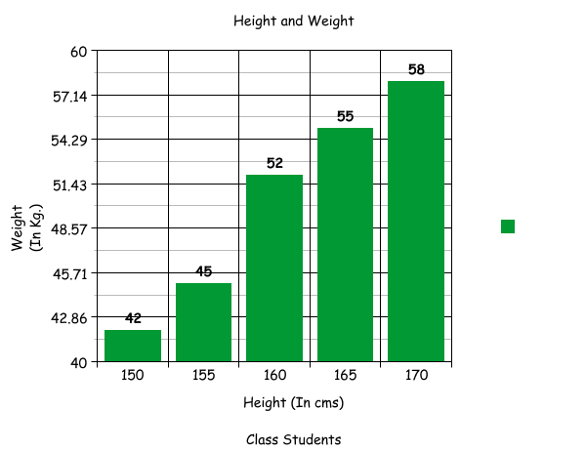
Steps to create a bar chart
- Enter the data in Excel.
- Select the data range.
- Go to Insert → Bar Chart → Choose a chart type (e.g., Clustered Bar).
- Customize the chart title, axes, and legend.
- Change chart style and design if desired.

ENGREG HIGH SCHOOL
24, Bankole Street, Pedro, Shomolu, Lagos
WEEK: 9 FIRST TERM SESSION: 2024/2025
SUBJECT: COMPUTER STUDIES |  | TOPIC: LINE GRAPH
CLASS: JSS 3 | DATE: 4th – 8th November, 2024. | REFERENCE BOOKS: New Computer Studies for JSS 3 by J.O.E Otuka et al Pages 19-21  WABP ICT for JSS 3 by Vincent Hope et al Pages 20-23
LEARNING PURPOSE:  To provide foundational knowledge on the definition of line graph and the steps to create and edit a line graph. |  |  |  | LESSON PERIOD: 2  DURATION: 40 MINS
LEARNING OBJECTIVE: By the end of the lesson, students will be able to:  - Explain the Line Graph.  - State the steps to create and edit a line graph. |  |  |  | KEYWORDS: Graph, Line Graph, Bar Chart, Histogram, Pie Chart.
PREVIOUS LEARNING: The students have been taught the Definition of Graph, Types of graph and steps to create a graph. |  | INSTRUCTIONAL MATERIALS:  Interactive board, computer system, Internet
LEARNING ACTIVITIES IN STEPS:  Step 1: The teacher marks assignment and makes correction.  Step 2: The teacher asks questions on previous knowledge  Step 3: The teacher modifies students’ response and introduces the new topic  Step 4: Students would be taken through the derailed explanation of the lesson content  Step 5: Students ask questions on the content of the lesson  Step 6: Students would be evaluated based on behavioural objectives  Step 7: Students Assignments are given and notes are marked |  |  | LEARNING TIME FOR EACH STEP:  Step 1: 3mins  Step 2: 2mins  Step 3: 3mins  Step 4: 20mins  Step 5: 2mins  Step 6: 7mins  Step 7: 3mins
LEARNING SKILLS:  Critical thinking, creative thinking, communicating and leadership development |  | ACTIVITY  - Explain the Line Graph.  - State the steps to create a line graph.
EVALUATIVE QUESTIONS:  - Explain the Line Graph.  - State the steps to create and edit a line graph. |  | ASSIGNMENT  State the steps to edit a line graph.

LINE CHART:
A line chart displays data points connected by straight lines. It is useful for showing trends or changes over time.
Example: Showing the temperature changes over a week or tracking a student’s grades over a semester.

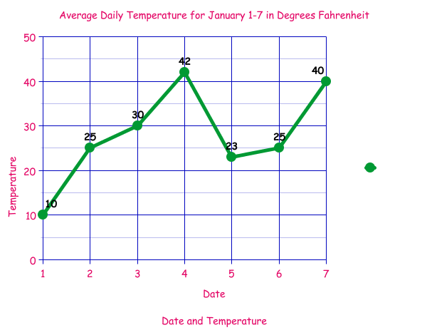

Steps to create a line graph:
- Organize your data into a table with rows for the X and Y variables.
- Choose your graphing tool
- Select the data and choose the "Line Chart" option to create the graph.
- Label the axes and title the chart appropriately.

Editing Line Graphs:
- Change data range: Adjust the data series if you need to add or remove data points.
- Modify axes: Format the X and Y axes by adjusting scales, changing labels, or modifying the axis title for clarity.
- Add markers: Highlight specific data points with markers for better visualization.
- Add gridlines: Include or modify gridlines for easier interpretation of the data.

